AT THE PICNIC
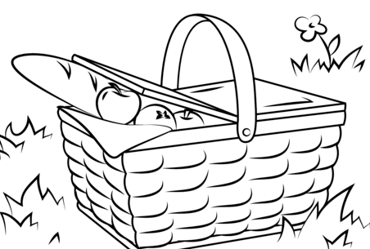

I ate
I learnt (new words)

___________________________________________________________________________

AT THE PICNIC

I ate
I learnt (new words)

